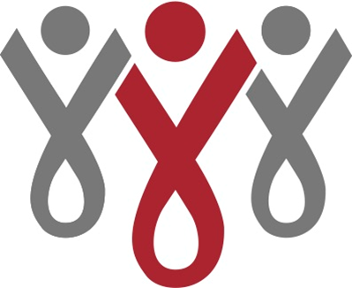
Job Posting: Kitchen Assistant

This part time (12-18 hours/week) non-benefits position contributes to The Aliveness Project’s mission by assisting in food preparation and service at the drop-in, from scratch, cafeteria in our community center in Minneapolis.

Responsibilities:
- Assist with kitchen production (prep work, entrée, soup, and pastry preparation, salad bar set-up, stocking the beverage dispenser)
- Accept and put away food deliveries; organize walk-in cooler and freezer
- Assist on the serving line and with dishwashing duties as needed
- Maintain a positive, professional, team-oriented approach when interacting with fellow staff, volunteers, and the public
- Cover employees during vacation or absences
- Adhere to established standards for sanitation, cleanliness and safety throughout kitchen areas at all times
- Help maintain equipment and kitchen/storage/dining areas according to MN food code rules

Preferred Education and Experience:
* ServSafe certification/equivalent, or willing to take ServSafe certification within 30 days of hiring
* Ability to read and follow a recipe.
* Knowledge of and sensitivity to HIV/AIDS, including nutritional issues that affect PLWHA
* Willingness to be on-call to provide additional coverage for occasional absences/vacation coverage
* Ability to lift up to 50 pounds
* Bilingual (English/Spanish) preferred

Regular shifts: Varies - 6 hour shifts between the hours of 9am-8pm, starting at $12.25/hr.
To apply: submit resume to Laura Hutchinson, Nutrition and Wellness Programs Director, lauras@aliveness.org
Our Mission
The Aliveness Project links people living with HIV to resources for leading healthy, self-directed lives.
Our Vision
Across Minnesota, there is decreased stigma of HIV/AIDS, increased access to services, and better health outcomes for people living with HIV. The Aliveness Project’s members feel supported as part of a safe community center that maximizes their health and wellbeing. Staff reflect the epidemic; deliver programs that evolve from member needs and a changing environment; and dedicate themselves to the overall health of the Aliveness community.
Equal Opportunity Employer
The Aliveness Project is an Equal Opportunity Employer and does not discriminate on the basis of actual or perceived race, color, national origin, ancestry, sex, gender, gender identity, and gender expression, religious creed, disability (mental and physical) including HIV, AIDS, and AIDS-related conditions, medical condition (including cancer and genetic characteristics), genetic information, age, marital status, sexual orientation, military and veteran status, or any other characteristic protected by federal, state or local law. People of color, women, trans and gender-nonconforming people, and applicants with backgrounds and lived experiences connected with The Aliveness Project’s mission and/or who personally identify with the community groups we support are strongly encouraged to apply.

www.aliveness.org

